Sample Custom Query for HFA Spreadsheet for BPS 1 – 2-Step Eligibility Process
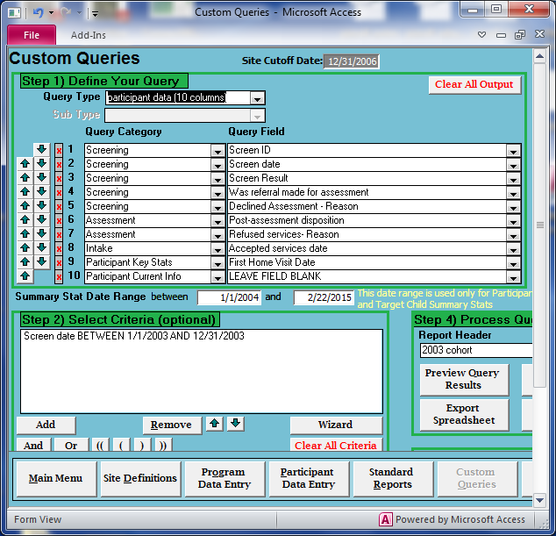

Sample Custom Query for HFA Spreadsheet for BPS 1 – Demographics
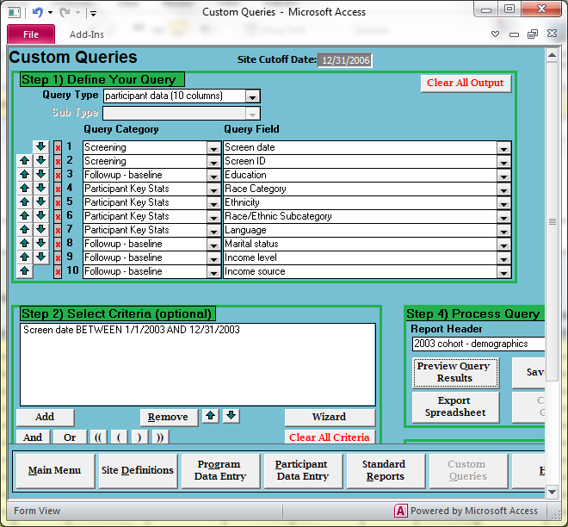

Sample Custom Query for HFA Spreadsheet for BPS 1 – Programmatic Factors
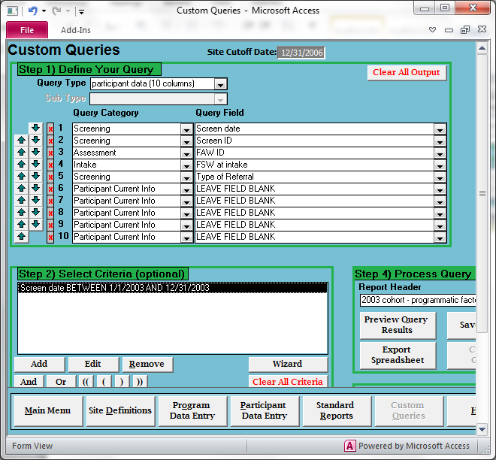

Sample Custom Query for HFA Spreadsheet for BPS 1 – Social Factors
