Description of the problem

This problem, which occurs at least in PIMS 8.0.13 through 8.0.17, manifests itself in several different ways.
- When trying to open some reports including PIMS16E: Monthly Case Management: Adjusted Expected Home Visits, you get an error stating that “This expression is typed incorrectly, or it is too complex to be evaluated.”

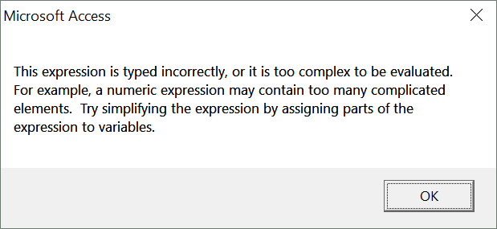

- Reports such as PIMS16E: Monthly Case Management: Adjusted Expected Home Visits and PIMS35A: Home Visit Completion by Individual show a home visit completion rate of 0% even when you know home visits have been completed.
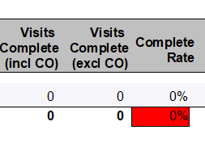

Cause of the Problem

This problem can be triggered in the following ways:
- One or more Service History Form records were created, with no Level of Service specified.
- A record was deleted from the Service Level Definitions Form corresponding to a service level that had actively been used.

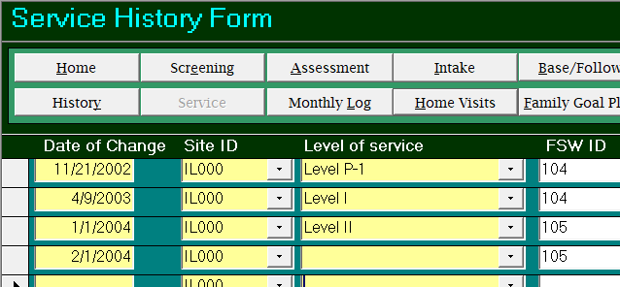

Fixing this Problem
To fix this problem, you can try the following:
- If the problem occurs in more recent months, create a Custom Query to identify the missing service level assignment.

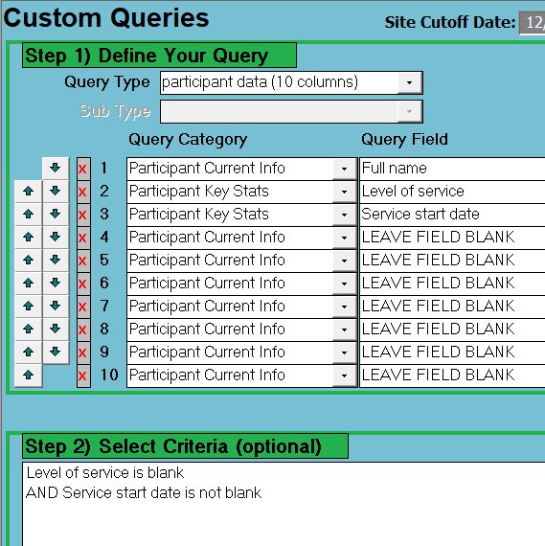

- If the problem occurs for older months, try to run the problematic reports for a few different months, to determine exactly when the problem occurs. Based on who had switched service levels during these time periods, check the Service History Form records for those participants and correct any missing entries.
- Go to the PIMS Start Menu, then DB Administration.
- Click on Refresh Svc Level Stats.
- Re-run the problematic reports.

Technical Solution
The following troubleshooting tips are intended for tech specialists who are comfortable working with PIMS data in Microsoft Access.
- Open the table tservice_level_history.
- Sort the table ascending by service_level_code and look for a blank service_level_code. If you find one or more blanks, this designates a record with a missing service level assignment. Make a note of the person_id, look up the person’s name in tparticipant_data, and then fix the problem for this person in the PIMS front end app.
- If #2 does not solve the problem, create a query joining tservice_level_history with tservice_level_data to find instances where there’s a service_level_code that’s NOT in tservice_level_data. This would suggest a service level that had been deleted. You will need to update service level history records to delete or reassign any assignment to deleted service levels.

Proposed Updates to PIMS
- The Service Level History Form should require that a service level is entered
- Service Level Definitions can’t be deleted if a given service level is used
- Refresh mechanism related to service levels needs to be automatically triggered

